# 

Project Report Templetes

1. INTRODUCTION

1.1 Overview

This project is very helpful the Revolution of Iphones, and it was very helpful to know the shares and the market values in the world.

It was very helpful to find the values of the Brand of Iphones in today market. This study will offer invaluable insights into the transformative impact of the iphone on India’s technological landscape and the lives of its consumers by using advanced data analytics techniques and analyzing large datasets.

1.2 Purpose

The iPhone capturing markets around the world, Apple inc. has emerged as a prominent player among the top smartphone makers. Each new iPhone model unvelling generates excitement and anticipation among Indian buyers. By utilising the plethora of information.

2. Problem Definition & Design Thinking

2.1 Empathy Map 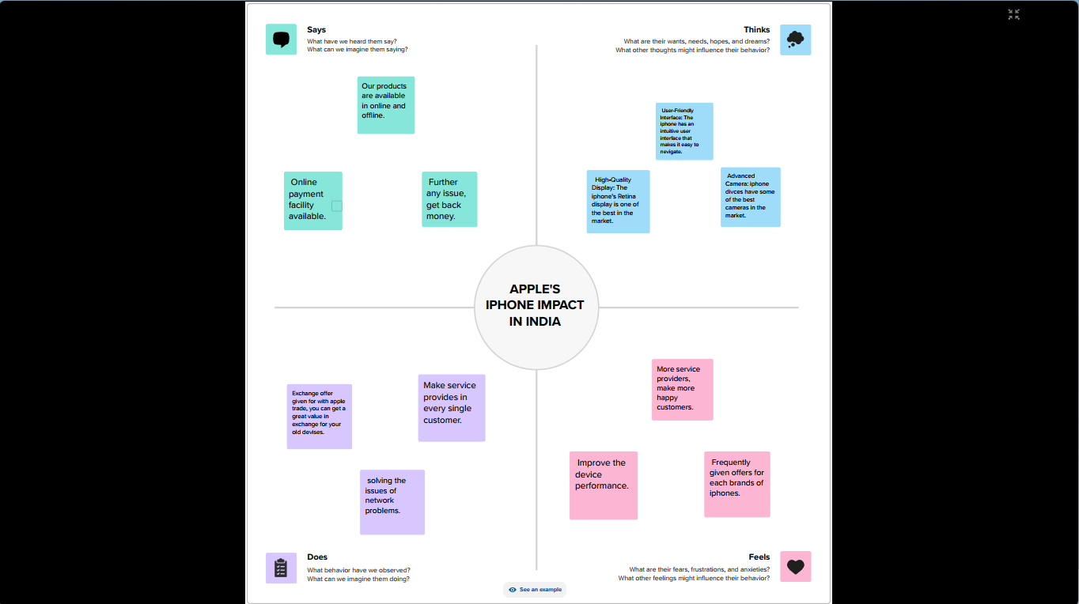

2.2 Ideation & Brainstroming Map

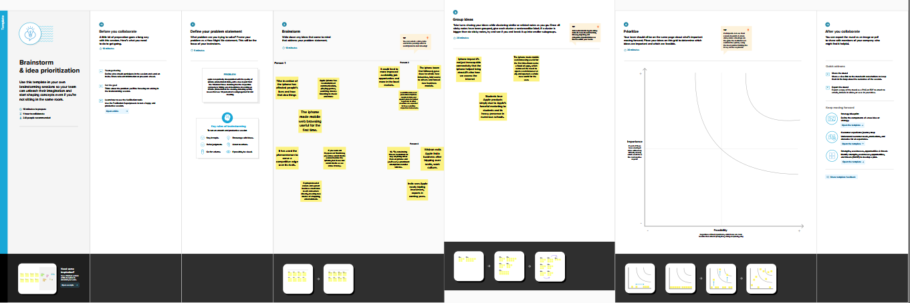

3 RESULT

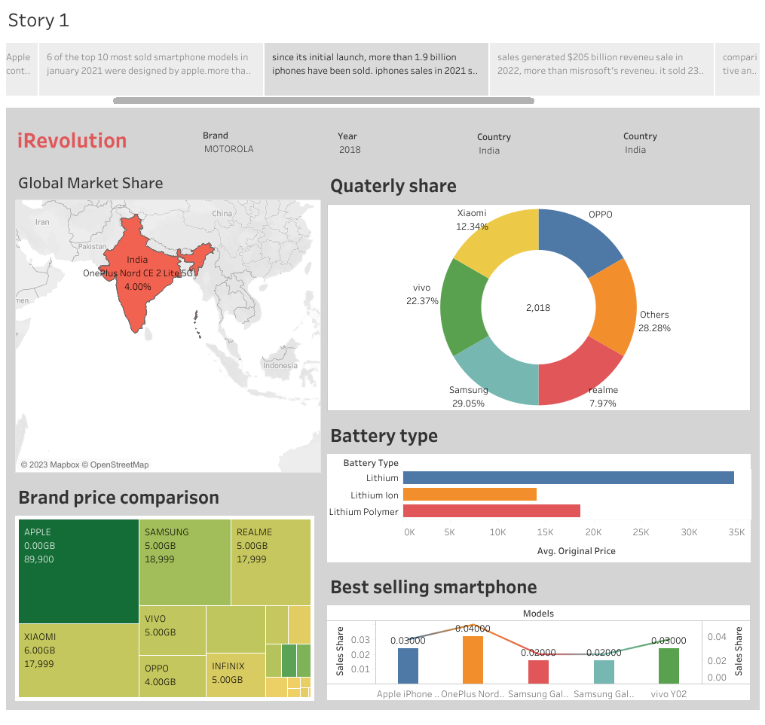

CONCLUTION

This project is very helpful to identity the Revolution of Iphones, and it was very helpful to know the shares and whole sold smartphones and markets values in the world.

FUTURE SCOPE

Iphone application development has become one if the highest-paying business, especially in the last couple of years, with business worldwide jumping onto the platform. It was very helpful to find the value of the brand of iphones in today market.